**Arduino Setup and Programming**

If you are using your Arduino with Windows all that you need to do is plug it into your computer and it should automatically install the drivers. Next, download the Arduino software from Here: <http://arduino.cc/en/main/software>

Using the Arduino and the LEDs included in the kit we can create different lighting regimes to attempt to control the amount of Red Fluorescent Protein produced and the amount of red color that we see from pDusk and pDawn.

An LED is pretty simple. It is a semiconductor that when we run current through it will create light!

Open up the arduino software and connect your arduino to a USB port on your computer. You should see lights begin to flash on your arduino. If not there is a problem!

The simplest way to make an LED light up is to connect a wire from the point on the arduino that says 3V3(3.3 Volt output) to the long pin of the LED and one of the points on the arduino that says GND(Ground) to the short pin on the arduino. You can do this easily using a solderless breadboard. The way that the solderless breadboard works is that each row is connected to each other except for the outside columns. So plug a wire in the same row as the long LED pin to the 3V3 and the connect the short pin using a wire to the GND point on the arduino. You can bend the LED pins to point the LED at a plate. The blue light should activate transcription of RFP.

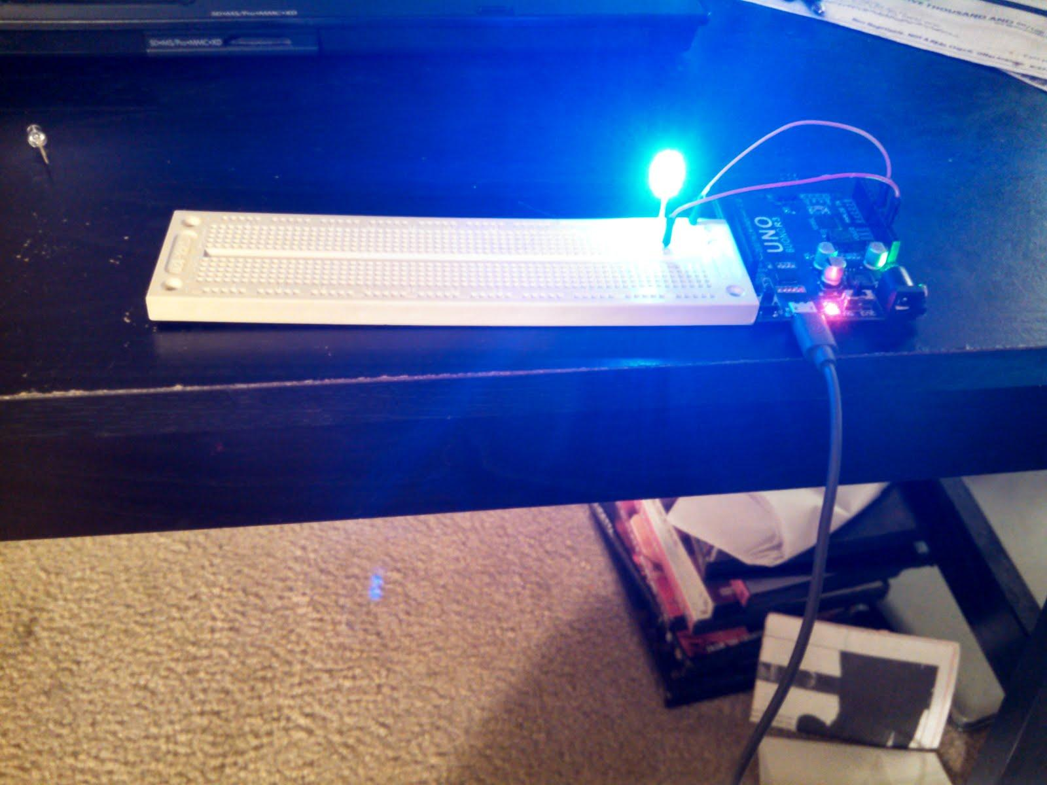

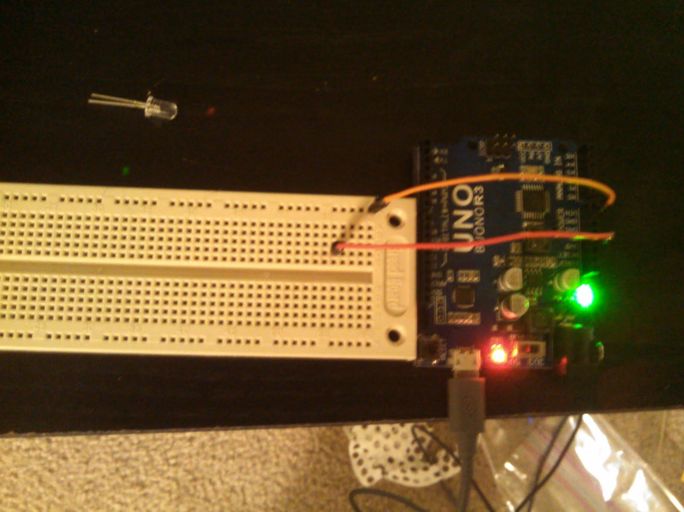

Ok now what if we want to do something more complicated such as test out different frequencies of light pulses or different amounts of light, we can do both of these using the arduino.

Open up the arduino program. Delete all the code that you see in the window and copy and paste this code:

// Set the LED pin

int LED = 3;

void setup() {

 // initialize the digital pin as an output.

 pinMode(LED, OUTPUT);

}

// the loop routine runs over and over again forever:

void loop() {

 digitalWrite(LED, HIGH);   // turn the LED on (HIGH is the voltage level)

 delay(1000);               // wait for a second

 digitalWrite(LED, LOW);    // turn the LED off by making the voltage LOW

 delay(1000);               // wait for a second

}

Now goto the tools option and then Serial Port and select the port if it is not selected. If there is more than one port chose the one with the highest number at the end. You should see a checkmark symbol and a right hand arrow symbol. Click on the right hand arrow symbol, this will compile and upload your code to the arduino. If it doesn’t work try switching to the other serial port. If there is not more than one serial port unplug your arduino and plug it back in and retry. If it still doesn’t work try restarting your computer. Then if there is nothing.

The program should turn the LED on for one second and then off for one second. Buuuuut we need to take the wire that is plugged into 3V3 and instead plug it into the point that has #3. Frequency of light should change how transcription of the RFP works. Try longer or shorter delays to see if you can find an optimum for RFP expression. These numbers will be different depending on the temperature and environment the plate or culture is in.

You can even do this for multiple LEDs. Instead of connecting one connect more! All of them can be connected to the same GND(Ground) but need to be connected to different outputs. So connect each LEDs long pin to a different input above #3(don’t connect them to the A0-A5 pins). Now you can change the code to add in more LEDs:

// Set the LED pin

int LED1 = 3;

int LED2 = 4;

void setup() {

 // initialize the digital pin as an output.

 pinMode(LED1, OUTPUT);

 pinmode(LED2, OUTPUT);

}

// the loop routine runs over and over again forever:

void loop() {

 digitalWrite(LED1, HIGH);   // turn the LED on (HIGH is the voltage level)

digitalWrite(LED2, HIGH);   // turn the LED on (HIGH is the voltage level)

 delay(1000);               // wait for a second

 digitalWrite(LED1, LOW);    // turn the LED off by making the voltage LOW

 digitalWrite(LED2, LOW);    // turn the LED off by making the voltage LOW

 delay(1000);               // wait for a second

}

If you want to make them flash at different times move the line with “digitalWrite(LED1, LOW);” before turning on LED2. You might want to also add in a delay or the LED with just blink off really fast.

To Add more LEDs do the same thing. Using these techniques you can test the effects of light on multiple cultures at the same time.